



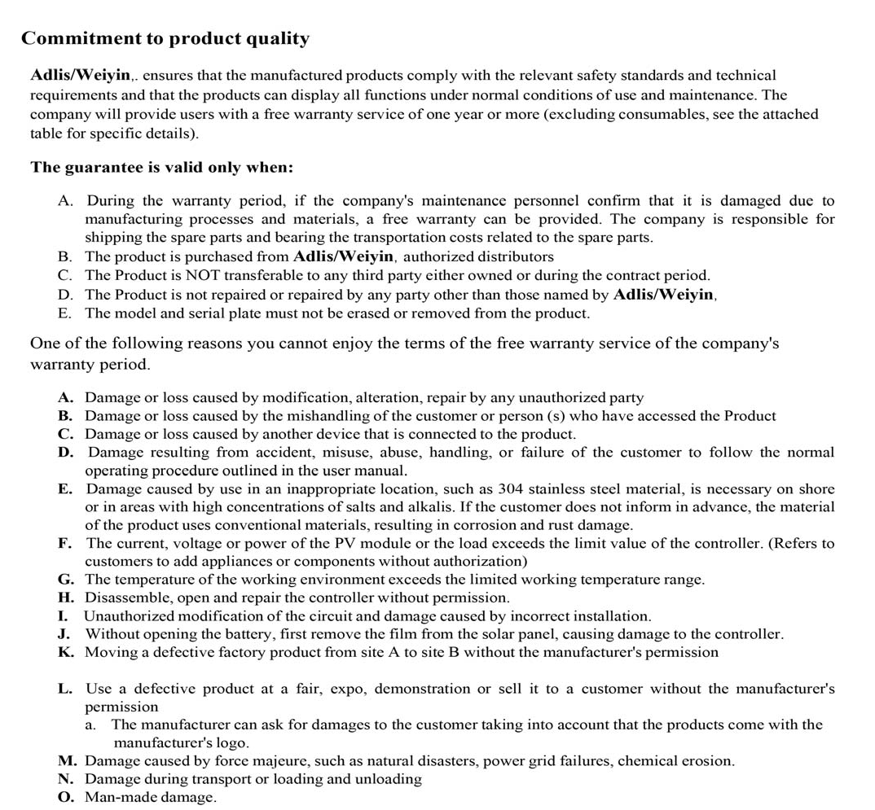

Adlis/Weiyin Corporation
Office: Sderot Moriah 104, Haifa – Israel Office: Asher 4 Kiryat Yam ‐ Israel Factory: Asher 4 Kiryat Yam – Israel
Factory: 2/F, Building E, Hengchangrong Industrial Park. Pinghu Street, Longgang District, Shenzhen City, Guangdong Province, China
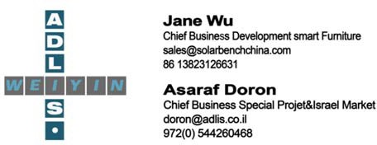

Adlis Smart, Co
Office: Sderot Moriah 104, Haifa – Israel Office: Asher 4 Kiryat Yam ‐ Israel Factory: Asher 4 Kiryat Yam ‐ Israel

General maintenance and service.
In the rare event that your machine arrives and fails, defective or broken the only course of action is to repair or replace

To comply with the guarantee, the following must be followed:
- Immediately ship replacement equipment or repair equipment.
- If your steam engine or equipment needs repairs, the customer should contact Adlis/Weiyin and receive a report with Authorization Number (RA) and all the information necessary for the repair or return.
- Adlis/Weiyin will not accept returns without a duly.
- All returns must be properly packaged to avoid damage during shipping. An explanation of the problem or damage and a Proof of Purchase must be presented with the return.
- The RA number must be clearly visible on the returned package.
- The customer will be responsible and shipping costs, insurance of the merchandise. Because Adlis/Weiyin will not be responsible for Damage or loss during shipping.
- Warranty is void if: Damage is the result of accident, abuse, alteration, unauthorized use, force majeure, or use of other electricity than indicated on the product.
- The warranty is void if: a person who did not make repairs, modifications or alterations authorized by

Adlis/Weiyin.
- The warranty is void if: the client did not perform the required routine maintenance and the damages or problems are directly related to say negligence. It is the responsibility of the client to maintain equipment in good condition.
Manufacturers will not be responsible for monetary damages or losses related to the purchase or use of their equipment. Adlis/Weiyin excludes its responsibility for all physical and moral damages linked to the purchase and use of its products. In all cases, damages cannot exceed the purchase price paid by the initial owner.
The final decision to fulfill the warranty is made by Adlis/Weiyin staff after a technical inspection and after the owner returns the defective products.

Full refund accepted by the manufacturer.
- The customer will have to return the products to his account and cost for a full refund.
- Only after receiving the products the manufacturer will return the amount paid by the customer
- The costs of flights, extra charges, taxes or others will not be returned if they were not contracts in the purchase order of the product (EXW)
- Once the product is sold, and there is no quality problem, no returns will be accepted.
- After the warranty period, the buyer can buy the accessories from the factory normally, and the freight is on their own.

Warranties are NON TRANSFERABLE

POST SALE SERVICE
Because we think a strong post sale service is fundamental, we provide every new client with FREE training on every Smart Products of Adlis/Weiyin,.

TECHNICAL SUPPORT
Adlis/Weiyin, are equipped with an extremely knowledgeable and certified team of technicians who are available to assist you with any questions or needs that you have
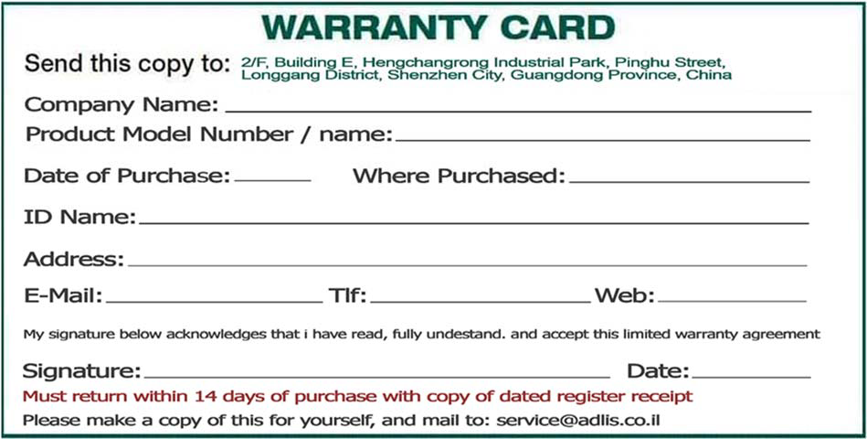

- The customer will have to return the products to his account and cost for a full refund.
- If your steam engine or equipment needs repairs, the customer should contact Adlis / Weiyin and receive a report with Authorization Number (RA) and all the information necessary for the repair or return.
- Adlis/Weiyin will not accept returns without a duly.
- All returns must be properly packaged to avoid damage during shipping. An explanation of the problem or damage and a Proof of Purchase must be presented with the return.
- The RA number must be clearly visible on the returned package.
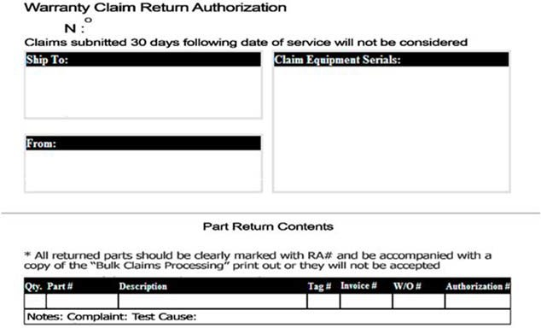

Smart product quality assurance project
Warranty Items | Warranty period | Warranty
Main structure of smart products | 2 years | The main structure is not deformed.
Plastic Wood (WPC) | 2 years | The main structure is not deformed or cracked.
Surface paint | 2 year | Special Paint
Solar panels | 2 years | Normal use
Controller | 1 year | Normal use
battery | 1 year | Normal use
Wireless charging panel | 1 year | Normal use
Light strip | 1 year | Normal use
Light box | 1 year | Normal use
Led Screen | 1 year | Normal use
WiFi module | 1 year | Normal use
Bluetooth speaker | 2 year | Normal use
Smart speaker | 2 year | Normal use
USB charging cable | N/A | Normal use
warranty not cover the charging cables. We have no control over how users treat the cables once the product is installed on your premises. Replacement cables can be purchased at and additional cost.

Adlis Smart / Weiyin Technology Co.,Ltd stamp：
